## What should I know?

* Pre-requisites
  + OOP basic knowledge

## Installing Dependencies

* Pre-requisites
  + JDK11 (We recommend using [brew](https://brew.sh/), use the following [instructions](https://medium.com/w-logs/installing-java-11-on-macos-with-homebrew-7f73c1e9fadf), or you can use this [link](https://www.oracle.com/technetwork/java/javase/downloads/jdk11-downloads-5066655.html) for normal JDK download or for any other OS than MacOS)
  + [IntelliJ](https://www.jetbrains.com/idea/download/#section=mac)

## Objectives

* Create a “Hello Java!” running class using the main method.
* Use the arguments passed as parameters to the main method.

Steps:

1. Open IntellJ and select Create a new project:  
   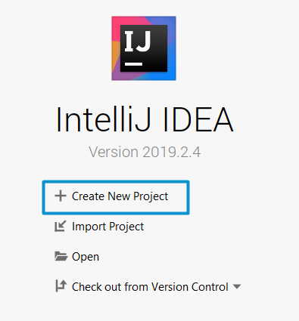
2. Select Java in the left panel and click Next until the name of the project is required:  
   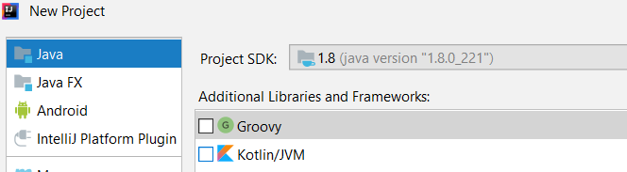
3. Fill the name and location of the project:  
   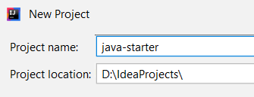
4. Open the project in the project tab on the left:  
   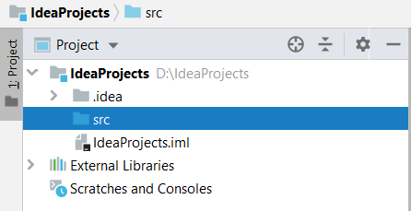
5. Right click on the src folder and create a new package:  
   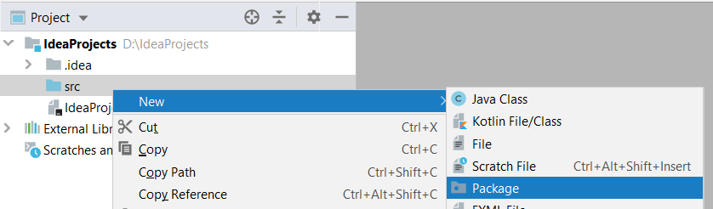  
     
   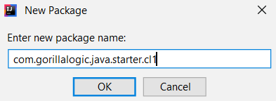
6. Right click on the package and create a new class:  
     
     
   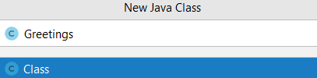

The new class should look like this:  
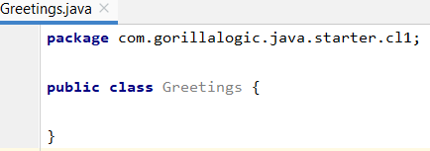

**Note**: you can check how the packages and classes are stored in filesystem. Each class is saved in java in a file call ClassName.java, an inconsistency between the filename and the class name will lead to a compilation error.  
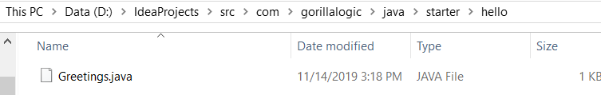

1. Add a main method inside the brackets of the Greetings class by typing it or by writing *ma* and then pressing Ctrl+Space:  
   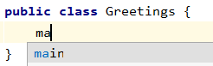

Now the class should be:  
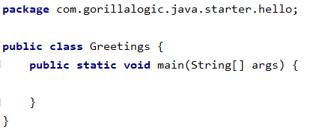

1. Now let’s print something in the console by calling the method System.out.println inside the main method (it can be typed or we can type *syso* and press TAB to generate it:  
   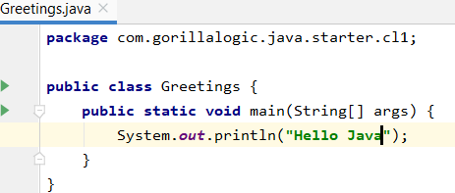
2. To run our first java program, press right click on the class and select:  
     
     
   We will see the console with our message and the finish of our program.  
   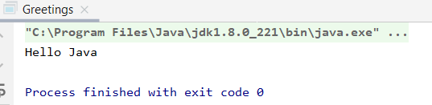
3. But what if we want to modify the program to use an argument:  
   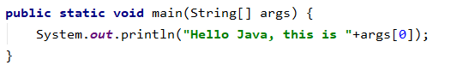
4. If we run it as we did before we will have an error because we are not passing any argument. To pass the argument go to the top right of your IDE and locate:  
   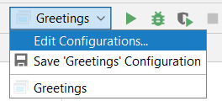
5. Write the parameter that you want to pass to the main method and press OK:  
   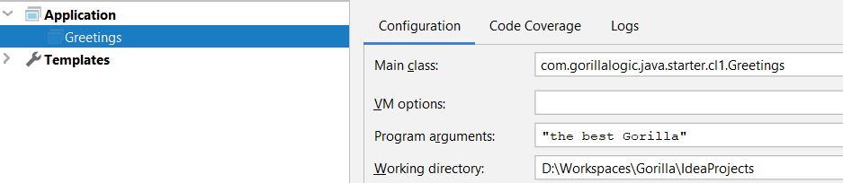
6. Run your program again:  
   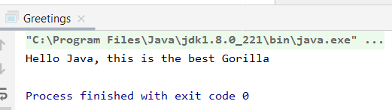

NOTE: If you want to pass more than one parameters those should be separated by spaces and referenced in the code as args[0], args[1]… args[n]